
Anatomy & Physiology Part Two Exam

Multiple Choice (worth 2 points each): Enter your selected answer into the blank space provided.

Please read these instructions before you begin to answer the questions that follow.
You are welcome to work your answers on this paper examination for your convenience. You will submit your final answers through an uploaded file through our app. When you are satisfied that your answers are correct, use the app to download an instruction file for the corresponding lesson. This will open the lesson, so you are able to add your work for grading. Complete this file upload for grading. Only the answers on the submitted file will be considered for grading.

You have reached the end of Part 2 and are ready for your Part 2 Examination. After you complete it, log in and submit through the app. Good luck!

Instructions:
Follow the instructions for each question. Show your work in the space provided and write the answer on the line. You will need to show your work on the file submitted to your teacher for grading.

_____1. Which of the following are NOT organs of the respiratory system?
  - nose
  - esophagus
  - pharynx
  - larynx

_____2. Nasal conchae increase turbulence of air flow to trap particles in the mucus membranes and increase _____ needed for filtering air.
  - surface area
  - tension
  - nasal capacity
  - volume

_____3. What structure, found in the pharynx, is the body’s first line of defense against infection?
  - uvula
  - tongue
  - tonsils
  - palate

_____4. True or False: The diaphragm relaxes to decrease the space in the thoracic cavity in order to expel air from the lungs.
  - True
  - False

_____5. Sinusitis can be caused by ___________________.
  - fungi
  - bacteria
  - viruses
  - all of the above

_____6. Bronchitis is considered chronic when a person has a cough that has lasted ______________.
  - 2 to 3 weeks
  - 5 or 7 days
  - 3 months to 2 years
  - ten years or longer

_____7. Oxygen binds to the iron molecule called ______________.
  - hemoglobin
  - heme
  - globin
  - oxyhemoglobin

_____8. White blood cells use _________________ to leave the blood.
  - homeostasis
  - platelets
  - enzymes
  - diapedesis

_____9. True or False: Red blood cells have an unlimited life span.
  - True
  - False

_____10. To develop sickle cell anemia, you must inherit the sickle cell gene from ___________.
  - your mother
  - your father
  - both parents
  - your grandfather

_____11. The overproduction of red blood cells is known as what disorder?
  - leukemia
  - jaundice
  - hemophilia
  - polycythemia

_____12. A person with AB blood type has which antigens on their blood cells?
  - A
  - B
  - all of the above
  - none of the above

_____13. Which valve prevents back flow into the left atria?
  - mitral valve
  - tricuspid valve
  - aortic valve
  - semilunar valve

_____14. Which of the following is NOT true about blood flow through the heart?
  - the pulmonary carries deoxygenated blood to the lungs
  - blood from the left atrium flows through the left mitral valve
  - deoxygenated blood enters the heart through the inferior and superior vena cava
  - blood flows from the right atrium through the bicuspid valve to the right ventricle

_____15.True or False: The pulmonary arteries carry deoxygenated blood.
  - True
  - False

_____16. Which of the following is NOT true about veins?
  - veins deal with low pressure
  - veins do not have valves
  - capillaries and venules precede larger veins
  - the respiratory system aids in venous return

_____17. Which layer provides a smooth frictionless surface for the flow of blood in a vessel?
  - tunica media
  - tunica intima
  - tunica externa
  - medulla oblongata

_____18. Atherosclerosis is known as hardening of the ____________________.
A. veins
B. blood vessels
C. arteries
D. athero

_____19. What cell is important in destroying cancer cells and virus infected cells?
  - T lymphocytes
  - B lymphocytes
  - macrophages
  - natural killer cells

_____20. Which lymphatic organ cleanses blood?
  - thymus
  - lymph nodes
  - spleen
  - liver

_____21. The process by which compliment proteins make cells more attractive to phagocytes is called _______.
  - opsonization
  - activation
  - phagocytosis
  - precipitation

_____22. Mechanical breakdown occurs in what structure?
  - small intestine
  - stomach
  - esophagus
  - large intestine

_____23. Which of the following is solid at room temperature?
  - monounsaturated fats
  - polyunsaturated fats
  - trans-unsaturated fats
  - both a and b

_____24. Which digestive activity is initiated by swallowing and peristalsis?
  - ingestion
  - mechanical breakdown
  - chemical breakdown
  - propulsion

_____25. What provides support to the small intestines as the body moves?
  - submucosa
  - mesentery
  - muscularis externa
  - serosa

_____26. What structure on the tongue grips food and houses taste buds?
  - papillae
  - uvula
  - micro villi
  - orbicularis

_____27. All the following are true about teeth and gums EXCEPT:
  - the canine teeth are adapted for cutting food
  - the gingiva covers the necks of the teeth down to the lower mandible
  - the tooth body is made of the hard material dentin
  - the enamel is a hollow cavity that houses nerves

_____28. True or False: Smelling, seeing and tasting food alerts the parasympathetic nervous system that digestion is about to begin.
  - True
  - False

Use the image below to answer questions 29-30.
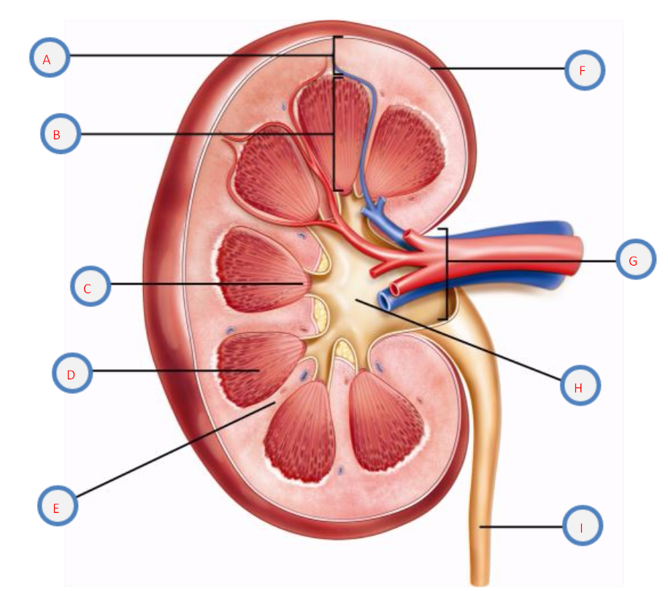

_____29. Which structure above is the renal medulla?
A. G B. E C. B D. A

_____30. The structure labeled _____ is the renal pelvis that drains into the ureter.
  - A
  - E
  - H
  - D

_____31. Which of the following allow water to easily enter and exit cells during reabsorption?
  - sodium-potassium pump proteins
  - aquaporin channels
  - cotransport proteins
  - renal tubules

_____32. Which type of diabetes is an autoimmune disease?
  - type I
  - type II
  - diabetes insipidus
  - diabetes diuresis

_____33. True or False: Creatinine is a normal byproduct of muscle metabolism.
  - True
  - False

_____34. Which process creates four haploid cells?
  - mitosis
  - cell cycle
  - fertilization
  - meiosis

_____35. Which of the following are accessory glands in the male reproductive system?
  - seminal glands
  - bulbourenthral glands
  - prostate gland
  - all of the above

_____36. What hormone is released after childbirth stimulates milk production?
A. estrogen
B. progestogen
C. prolactin
D. semen

_____37. Testes are to ovaries as sperm are to _____.
  - blastocyte
  - oocyte
  - vagina
  - zygote

_____38. Why does ovarian cancer have a low survival rate?
  - symptoms are often not felt until the cancer has spread
  - the cell growth rate is higher than normal
  - there are no effective screening techniques
  - both a and c

_____39. True or False: A gamete has 46 chromosomes.
  - true
  - false

_____40. Which of the following helps create genetic diversity?
  - DNA
  - mitosis
  - crossovers
  - SRY genes

Essays (worth 20 points, 10 points each)

41. A: What can cause itchy watery eyes from exposure to dust, pet dander, and pollen?
B: Describe the bodies response and include two treatments.
__________________________________________________________________________________________________________________________________________________________________
__________________________________________________________________________________________________________________________________________________________________
__________________________________________________________________________________________________________________________________________________________________
___________________________________________________________________________________________________________________________________________________________________________________________________________________________________________________
___________________________________________________________________________________________________________________________________________________________________________________________________________________________________________________
___________________________________________________________________________________________________________________________________________________________________________________________________________________________________________________
___________________________________________________________________________________________________________________________________________________________________________________________________________________________________________________
___________________________________________________________________________________________________________________________________________________________________________________________________________________________________________________
___________________________________________________________________________________________________________________________________________________________________________________________________________________________________________________
___________________________________________________________________________________________________________________________________________________________________________________________________________________________________________________
___________________________________________________________________________________________________________________________________________________________________________________________________________________________________________________
___________________________________________________________________________________________________________________________________________________________________________________________________________________________________________________
__________________________________________________________________________________________________________________________________________________________________
42. Polyspermy occurs when more than one sperm succeeds in fertilizing the oocyte. What does this mean for the zygote? How is polyspermy prevented?
__________________________________________________________________________________________________________________________________________________________________
___________________________________________________________________________________________________________________________________________________________________________________________________________________________________________________
___________________________________________________________________________________________________________________________________________________________________________________________________________________________________________________
___________________________________________________________________________________________________________________________________________________________________________________________________________________________________________________
___________________________________________________________________________________________________________________________________________________________________________________________________________________________________________________
___________________________________________________________________________________________________________________________________________________________________________________________________________________________________________________
___________________________________________________________________________________________________________________________________________________________________________________________________________________________________________________
___________________________________________________________________________________________________________________________________________________________________________________________________________________________________________________
___________________________________________________________________________________________________________________________________________________________________________________________________________________________________________________
___________________________________________________________________________________________________________________________________________________________________________________________________________________________________________________
___________________________________________________________________________________________________________________________________________________________________________________________________________________________________________________
__________________________________________________________________________________________________________________________________________________________________
__________________________________________________________________________________________________________________________________________________________________
__________________________________________________________________________________________________________________________________________________________________
_________________________________________________________________________________

